**VISVESVARAYA TECHNOLOGICAL UNIVERSITY**

**“JnanaSangama”, Belgaum -590014, Karnataka.**



## LAB REPORT

**on**

Machine Learning (20CS6PCMAL)

***Submitted by***

## Siri Chandan Sai K(1BM19CS212)

***in partial fulfillment for the award of the degree of***

**BACHELOR OF ENGINEERING**

***in***

## COMPUTER SCIENCE AND ENGINEERING



**B.M.S. COLLEGE OF ENGINEERING**

(Autonomous Institution under VTU)

## BENGALURU-560019

**May-2022 to July-2022**

## B. M. S. College of Engineering,

Bull Temple Road, Bangalore 560019

(Affiliated To Visvesvaraya Technological University, Belgaum)

**Department of Computer Science and Engineering**



**CERTIFICATE**

This is to certify that the Lab work entitled “Machine Learning” carried out by Siri Chandan Sai K **(1BM19CS212),** who is bonafide student of **B. M. S. College of Engineering.** It is in partial fulfillment for the award of **Bachelor of Engineering in Computer Science and Engineering** of the Visvesvaraya Technological University, Belgaum during the year2022. The Lab report has been approved as it satisfies the academic requirements in respect of a **Machine Learning (20CS6PCMAL)** work prescribed for the said degree.

**Asha G.R** **Dr. Jyothi S Nayak**

Assistant Professor Professor and Head

Department of CSE Department of CSE

BMSCE, Bengaluru BMSCE, Bengaluru

**Index Sheet**

|  |  |  |
| --- | --- | --- |
| **Sl.**  **No.** | **Experiment Title** | **Page No.** |
| **1** | **Implement and demonstrate the FIND-S algorithm for finding the most specific hypothesis based on a given set of training**  **data samples.** |  |
| **2** | **For a given set of training data examples stored in a .CSV file, implement and demonstrate the Candidate-Elimination algorithm to output a description of the set of**  **all hypotheses consistent with the training examples.** |  |
| **3** | **Write a program to demonstrate the working of the decision tree based ID3 algorithm. Use an appropriate data set for building the decision tree and apply this knowledge to**  **classify a new sample.** |  |
| **4** | **Write a program to implement the naïve Bayesian classifier for a sample training data set stored as a .CSV file. Compute the accuracy of the classifier, considering few test**  **data sets** |  |
| **5** | **Implement the Linear Regression algorithm in order to fit data points. Select appropriate**  **data set for your experiment and draw graphs** |  |
| **6** | **Write a program to construct a Bayesian network considering training data. Use this model to make predictions.** |  |

|  |  |  |
| --- | --- | --- |
| **7** | **Apply k-Means algorithm to cluster a set of data stored in a .CSV file.** |  |
| **8** | **Apply EM algorithm to cluster a set of data stored in a .CSV file. Compare the results of k-Means algorithm and EM algorithm** |  |
| **9** | **Write a program to implement k-Nearest Neighbour algorithm to classify the iris data set. Print both correct and wrong predictions.** |  |
| **10** | **Implement the non-parametric Locally Weighted Regression algorithm in order to fit data points. Select appropriate data set for your experiment and draw graphs.** |  |

**Course Outcome**

|  |  |
| --- | --- |
| CO1 | Ability to apply the different learning algorithms. |
| CO2 | Ability to analyze the learning techniques for given dataset. |
| CO3 | Ability to design a model using machine learning to solve a problem. |
| CO4 | Ability to conduct practical experiments to solve problems using appropriate machine learning techniques |

# Implement and demonstrate the FIND-S algorithm for finding the most specific hypothesis based on a given set of training data samples.

import numpy as np import pandas as pd data=pd.read_csv ("testdemo.csv”) data

d = np.array(data)[:,:-1] print("\n The attributes are: ",d) target = np.array(data)[:,-1] print("\n The target is: ",target) def findS(c,t):

for i, val in enumerate(t):

if val == "Yes": specific_hypothesis = c[i].copy() break

for i, val in enumerate(c):

if t[i] == "Yes":

for x in range(len(specific_hypothesis)): if val[x] != specific_hypothesis[x]:

specific_hypothesis[x] = '?' else:

pass

return specific_hypothesis

print("\n The final hypothesis is:",findS(d,target))

**Dataset:**

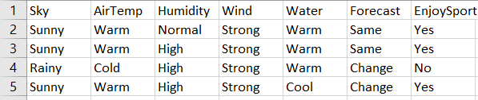

**Output:**

The final hypothesis is: ['?' 'Sunny' '?' 'Yes' '?' '?']

# For a given set of training data examples stored in a .CSV file, implement and demonstrate the Candidate-Elimination algorithm to output a description of the set of all hypotheses consistent with the training examples.

import numpy as np import pandas as pd

data=pd.DataFrame(data=pd.read_csv('candidate_elimina tion.csv'))

data concepts=np.array(data.iloc[:,0:-1])

print("The attributes are : ",concepts) target=np.array(data.iloc[:,-1])

print ("\n The target is =",target) def learn(concepts,target):

specific_h=concepts[0].copy()

print("\n Initialization of specfic_h and generalization") print(specific_h)

general_h = [["?" for i in range(len(specific_h))] for i in range(len(specific_h))] print(general_h)

for i,h in enumerate(concepts):

if target[i] =="yes":

print("If instance is positive") for x in range(len(specific_h)):

if h[x]!=specific_h[x]:

specific_h[x]='?' general_h[x][x]='?'

if target[i]=="no":

for x in range(len(specific_h)):

if h[x] !=specific_h[x]: general_h[x][x]=specific_h[x]

else:

general_h[x][x]='?'

print("steps of candidate elimination algorithm",i+1) print(specific_h)

print(general_h) print("\n")

print("\n")

indices=[i for i,val in enumerate(general_h) if val==['?','?','?']] for i in indices:

general_h.remove(['?','?','?']) return specific_h,general_h

s_final, g_final = learn(concepts, target) print("Final specific_h:",s_final,sep="\n") print("Final General_h:",g_final,sep="\n")

**Dataset:**



**Output:**

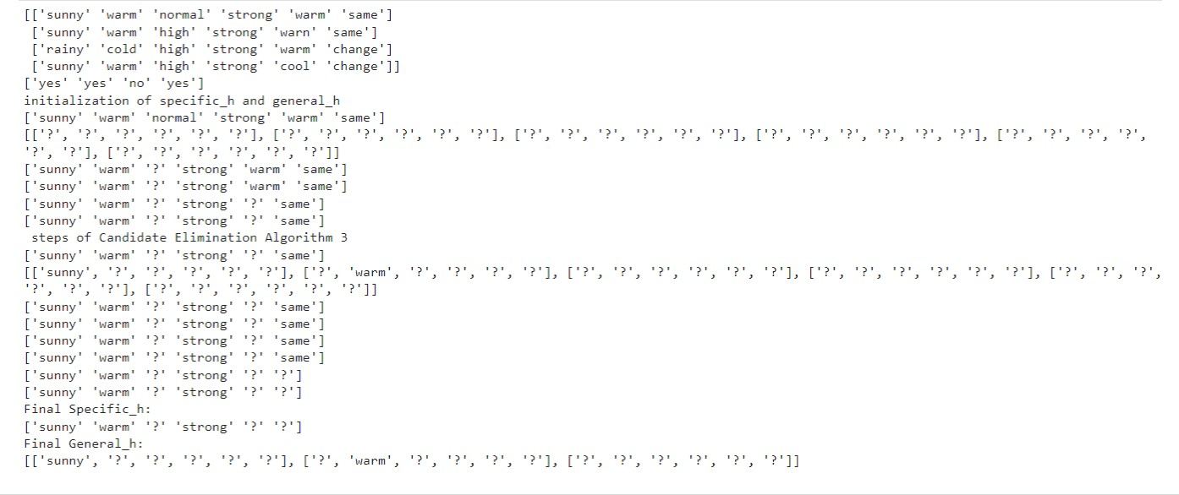

# Write a program to demonstrate the working of the decision tree based ID3 algorithm. Use an appropriate data set for building the decision tree and apply this knowledge to classify a new sample.

import math import csv

def load_csv(filename): lines=csv.reader(open(filename,"r")); dataset = list(lines)

headers = dataset.pop(0) return dataset,headers

class Node:

def init (self,attribute): self.attribute=attribute self.children=[] self.answer=""

def subtables(data,col,delete):

dic={}

coldata=[row[col] for row in data] attr=list(set(coldata))

counts=[0]*len(attr) r=len(data) c=len(data[0])

for x in range(len(attr)):

for y in range(r):

if data[y][col]==attr[x]:

counts[x]+=1

for x in range(len(attr)):

dic[attr[x]]=[[0 for i in range(c)] for j in range(counts[x])] pos=0

for y in range(r):

if data[y][col]==attr[x]:

if delete:

del data[y][col] dic[attr[x]][pos]=data[y] pos+=1

return attr,dic def entropy(S):

attr=list(set(S)) if len(attr)==1:

return 0

counts=[0,0] for i in range(2):

counts[i]=sum([1 for x in S if attr[i]==x])/(len(S)*1.0)

sums=0

for cnt in counts:

sums+=-1*cnt*math.log(cnt,2) return sums

def compute_gain(data,col):

attr,dic = subtables(data,col,delete=False)

total_size=len(data) entropies=[0]*len(attr) ratio=[0]*len(attr)

total_entropy=entropy([row[-1] for row in data]) for x in range(len(attr)):

ratio[x]=len(dic[attr[x]])/(total_size*1.0) entropies[x]=entropy([row[-1] for row in dic[attr[x]]]) total_entropy-=ratio[x]*entropies[x]

return total_entropy

def build_tree(data,features): lastcol=[row[-1] for row in data] if(len(set(lastcol)))==1:

node=Node("") node.answer=lastcol[0] return node

n=len(data[0])-1 gains=[0]*n

for col in range(n): gains[col]=compute_gain(data,col)

split=gains.index(max(gains)) node=Node(features[split])

fea = features[:split]+features[split+1:] attr,dic=subtables(data,split,delete=True)

for x in range(len(attr)): child=build_tree(dic[attr[x]],fea) node.children.append((attr[x],child))

return node

def print_tree(node,level): if node.answer!="":

print(" "*level,node.answer) return

print(" "*level,node.attribute) for value,n in node.children:

print(" "*(level+1),value) print_tree(n,level+2)

def classify(node,x_test,features): if node.answer!="":

print(node.answer) return

pos=features.index(node.attribute)

for value, n in node.children:

if x_test[pos]==value: classify(n,x_test,features)

'''Main program''' dataset,features=load_csv("id3.csv") node1=build_tree(dataset,features)

print("The decision tree for the dataset using ID3 algorithm is") print_tree(node1,0) testdata,features=load_csv("id3_test_1.csv")

for xtest in testdata:

print("The test instance:",xtest)

print("The label for test instance:",end=" ") classify(node1,xtest,features)

**Dataset:**

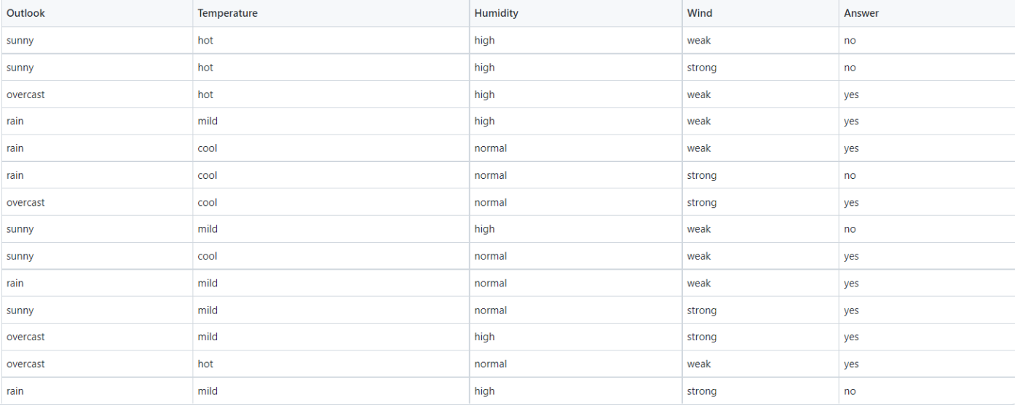

**Output:**

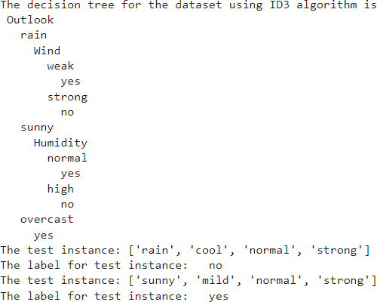

# Write a program to implement the naïve Bayesian classifier for a sample training data set stored as a .CSV file. Compute the accuracy of the classifier, considering few test data sets

import pandas as pd

from sklearn.model_selection import train_test_split from sklearn.naive_bayes import GaussianNB

from sklearn import metrics

df = pd.read_csv("diabetes.csv")

col_names = ['num_preg', 'glucose_conc', 'diastolic_bp', 'thickness', 'insulin', 'bmi', 'diab_pred', 'age'] predicted_class = ['diabetes']

X = df[col_names].values

y = df[predicted_class].values print(df.head)

xtrain,xtest,ytrain,ytest=train_test_split(X,y,test_size=0.4)

print ('\n the total number of Training Data :',ytrain.shape) print ('\n the total number of Test Data :',ytest.shape)

clf = GaussianNB().fit(xtrain,ytrain.ravel()) predicted = clf.predict(xtest)

predictTestData= clf.predict([[6,148,72,35,0,33.6,0.627,50]]) print('\n Confusion matrix') print(metrics.confusion_matrix(ytest,predicted))

print('\n Accuracy of the classifier is',metrics.accuracy_score(ytest,predicted)) print('\n The value of Precision', metrics.precision_score(ytest,predicted)) print('\n The value of Recall', metrics.recall_score(ytest,predicted)) print("Predicted Value for individual Test Data:", predictTestDat

**Dataset:**

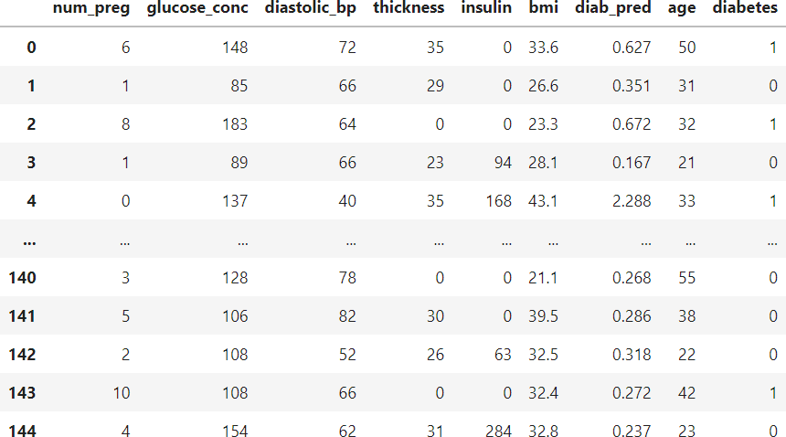

**Output:**

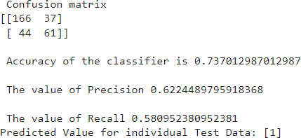

# Implement the Linear Regression algorithm in order to fit data points. Select appropriate data set for your experiment and draw graphs

import numpy as np

import matplotlib.pyplot as plt import pandas as pd

dataset = pd.read_csv('salary_data.csv')

X = dataset.iloc[:, :-1].values y = dataset.iloc[:, 1].values

from sklearn.model_selection import train_test_split

X_train, X_test, y_train, y_test = train_test_split(X, y, test_size=

***# Fitting Simple Linear Regression to the Training set* from sklearn.linear_model import LinearRegression regressor = LinearRegression()**

regressor.fit(X_train, y_train)

***# Predicting the Test set results***

y_pred = regressor.predict(X_test)

***# Visualizing the Training set results***

viz_train = plt

viz_train.scatter(X_train, y_train, color='red') viz_train.plot(X_train, regressor.predict(X_train), color='blue') viz_train.title('Salary VS Experience (Training set)') viz_train.xlabel('Year of Experience')

viz_train.ylabel('Salary') viz_train.show()

***# Visualizing the Test set results***

viz_test = plt

viz_test.scatter(X_test, y_test, color='red') viz_test.plot(X_train, regressor.predict(X_train), color='blue') viz_test.title('Salary VS Experience (Test set)') viz_test.xlabel('Year of Experience')

viz_test.ylabel('Salary') viz_test.show() regressor.score(X_train,y_train) print(regressor.score(X_test,y_test))

**Dataset:**

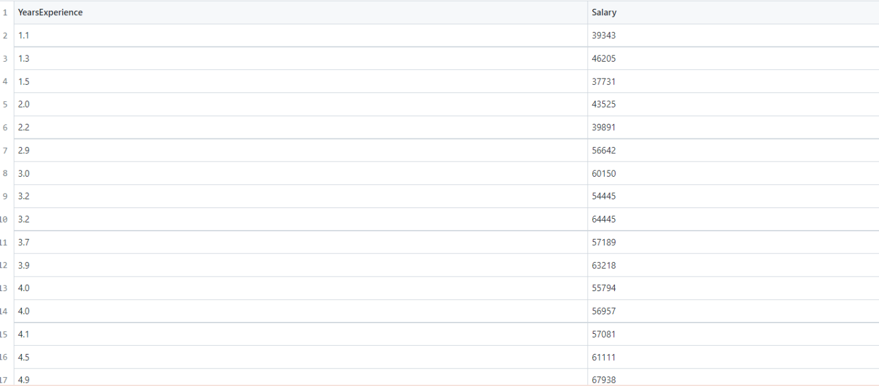

**Output:**

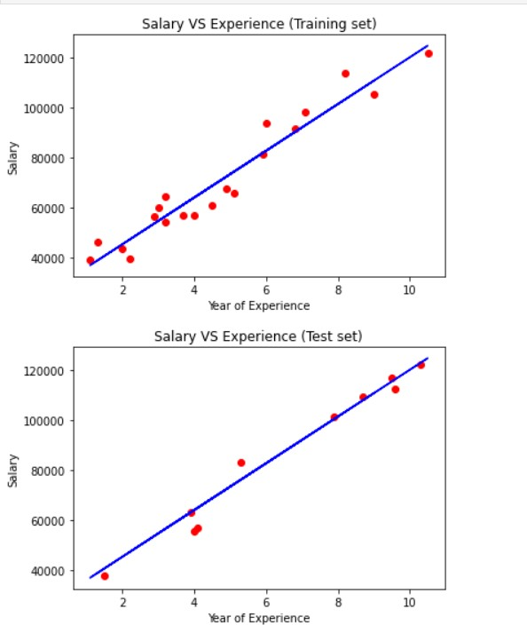

# Write a program to construct a Bayesian network considering training data. Use this model to make predictions

**import bayespy as bp**

**import numpy as np**

**import csv**

**!pip3 install colorama**

**!pip3 install colorama**

**from colorama import init**

**from colorama import Fore, Back, Style**

**init()**

**ageEnum = {'SuperSeniorCitizen': 0, 'SeniorCitizen': 1,**

**'MiddleAged': 2, 'Youth': 3, 'Teen': 4}**

**genderEnum = {'Male': 0, 'Female': 1}**

**familyHistoryEnum = {'Yes': 0, 'No': 1}**

**dietEnum = {'High': 0, 'Medium': 1, 'Low': 2}**

**lifeStyleEnum = {'Athlete': 0, 'Active': 1, 'Moderate': 2, 'Sedetary': 3}**

**cholesterolEnum = {'High': 0, 'BorderLine': 1, 'Normal': 2}**

**heartDiseaseEnum = {'Yes': 0, 'No': 1}**

**import pandas as pd**

**data = pd.read_csv("/content/heart_disease_data.csv")**

**data =np.array(data, dtype='int8')**

**N = len(data)**

**p_age = bp.nodes.Dirichlet(1.0*np.ones(5))**

**age = bp.nodes.Categorical(p_age, plates=(N,))**

**age.observe(data[:, 0])**

**p_gender = bp.nodes.Dirichlet(1.0*np.ones(2))**

**gender = bp.nodes.Categorical(p_gender, plates=(N,))**

**gender.observe(data[:, 1])**

**p_familyhistory = bp.nodes.Dirichlet(1.0*np.ones(2))**

**familyhistory = bp.nodes.Categorical(p_familyhistory, plates=(N,))**

**familyhistory.observe(data[:, 2])**

**p_diet = bp.nodes.Dirichlet(1.0*np.ones(3))**

**diet = bp.nodes.Categorical(p_diet, plates=(N,))**

**diet.observe(data[:, 3])**

**p_lifestyle = bp.nodes.Dirichlet(1.0*np.ones(4))**

**lifestyle = bp.nodes.Categorical(p_lifestyle, plates=(N,))**

**lifestyle.observe(data[:, 4])**

**p_cholesterol = bp.nodes.Dirichlet(1.0*np.ones(3))**

**cholesterol = bp.nodes.Categorical(p_cholesterol, plates=(N,))**

**cholesterol.observe(data[:, 5])**

**p_heartdisease = bp.nodes.Dirichlet(np.ones(2), plates=(5, 2, 2, 3, 4, 3))**

**heartdisease = bp.nodes.MultiMixture(**

**[age, gender, familyhistory, diet, lifestyle, cholesterol], bp.nodes.Categorical, p_heartdisease)**

**heartdisease.observe(data[:, 6])**

**p_heartdisease.update()**

**m = 0**

**while m == 0:**

**print("\n")**

**res = bp.nodes.MultiMixture([int(input('Enter Age: ' + str(ageEnum))), int(input('Enter Gender: ' + str(genderEnum))), int(input('Enter FamilyHistory: ' + str(familyHistoryEnum))), int(input('Enter dietEnum: ' + str(**

**dietEnum))), int(input('Enter LifeStyle: ' + str(lifeStyleEnum))), int(input('Enter Cholesterol: ' + str(cholesterolEnum)))], bp.nodes.Categorical, p_heartdisease).get_moments()[0][heartDiseaseEnum['Yes']]**

**print("Probability(HeartDisease) = " + str(res))**

**m = int(input("Enter for Continue:0, Exit :1 "))**

DATASET:

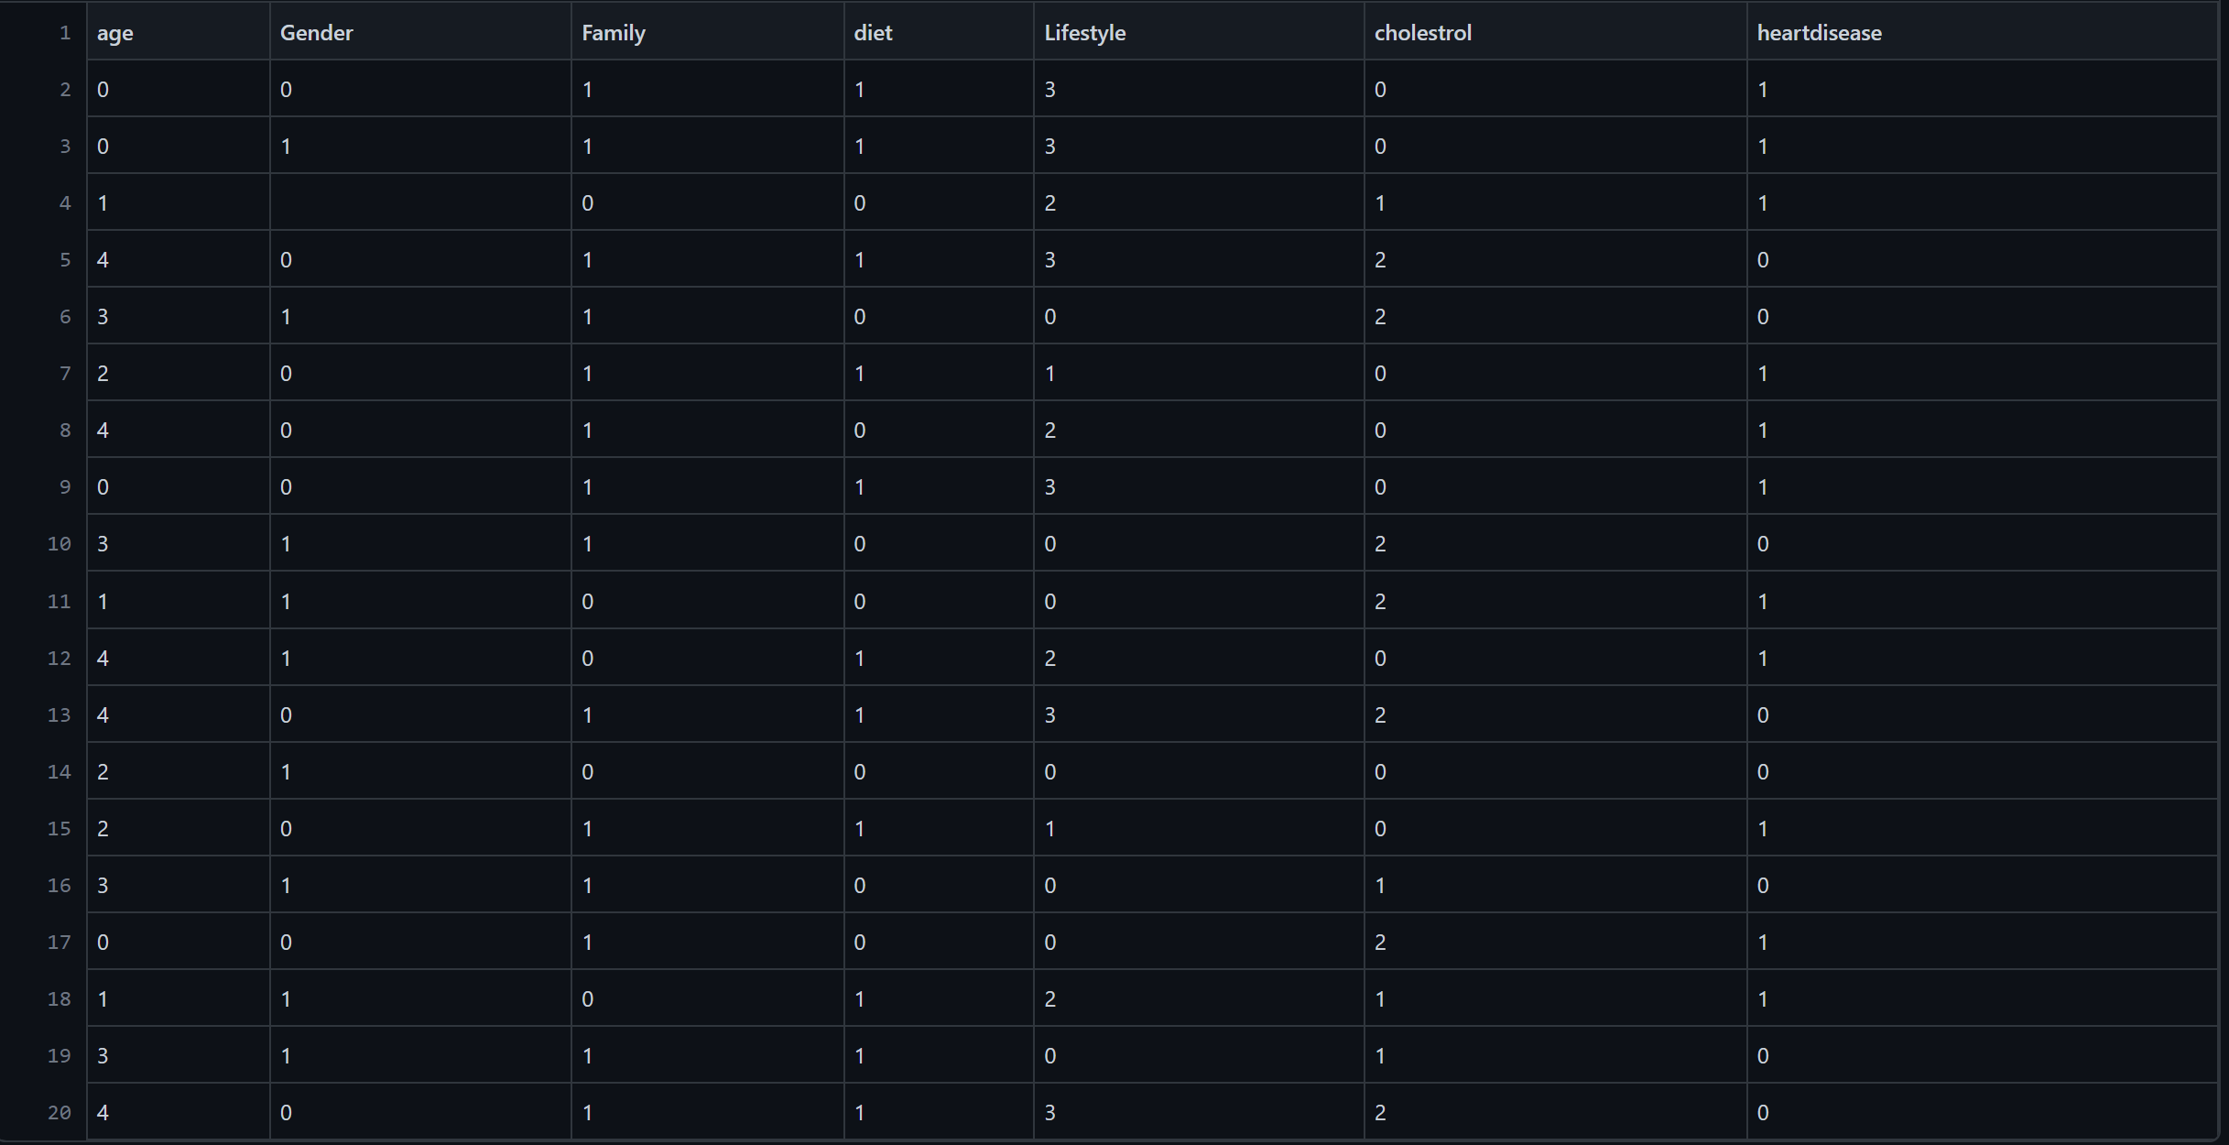

OUTPUT:

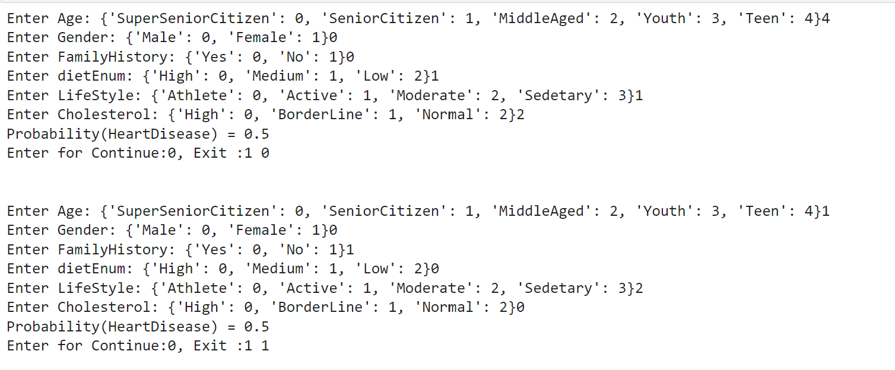

# Apply k-Means algorithm to cluster a set of data stored in a .CSV file

***#importing the libraries***

**import numpy as np**

**import matplotlib.pyplot as plt**

**import pandas as pd**

***#importing the Iris dataset with pandas***

**dataset = pd.read_csv('/content/Iris.csv')**

**x = dataset.iloc[:, [1, 2, 3, 4]].values**

***#Finding the optimum number of clusters for k-means classification***

**from sklearn.cluster import KMeans**

**wcss = []**

**for i in range(1, 11):**

**kmeans = KMeans(n_clusters = i, init = 'k-means++', max_iter = 300, n_init = 10, random_state = 0)**

**kmeans.fit(x)**

**wcss.append(kmeans.inertia_)**

***#Plotting the results onto a line graph, allowing us to observe 'The elbow'***

**plt.plot(range(1, 11), wcss)**

**plt.title('The elbow method')**

**plt.xlabel('Number of clusters')**

**plt.ylabel('WCSS') *#within cluster sum of squares***

**plt.show()**

***#Applying kmeans to the dataset / Creating the kmeans classifier***

**kmeans = KMeans(n_clusters = 3, init = 'k-means++', max_iter = 300, n_init = 10, random_state = 0)**

**y_kmeans = kmeans.fit_predict(x)**

***#Visualising the clusters***

**plt.scatter(x[y_kmeans == 0, 0], x[y_kmeans == 0, 1], s = 100, c = 'red', label = 'Iris-setosa')**

**plt.scatter(x[y_kmeans == 1, 0], x[y_kmeans == 1, 1], s = 100, c = 'blue', label = 'Iris-versicolour')**

**plt.scatter(x[y_kmeans == 2, 0], x[y_kmeans == 2, 1], s = 100, c = 'green', label = 'Iris-virginica')**

***#Plotting the centroids of the clusters***

**plt.scatter(kmeans.cluster_centers_[:, 0], kmeans.cluster_centers_[:,1], s = 100, c = 'yellow', label = 'Centroids')**

**plt.legend()**

DATASET:

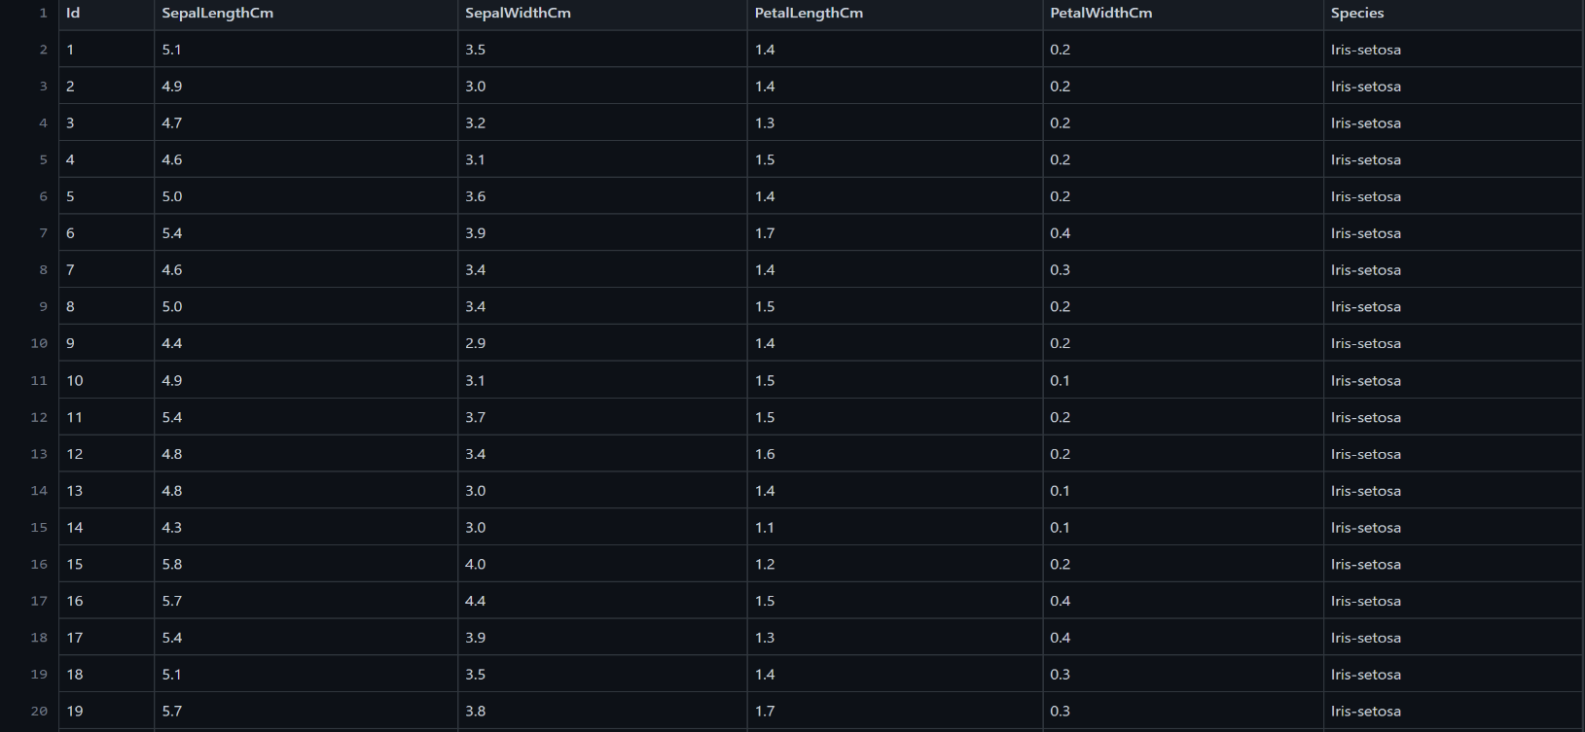

OUTPUT:

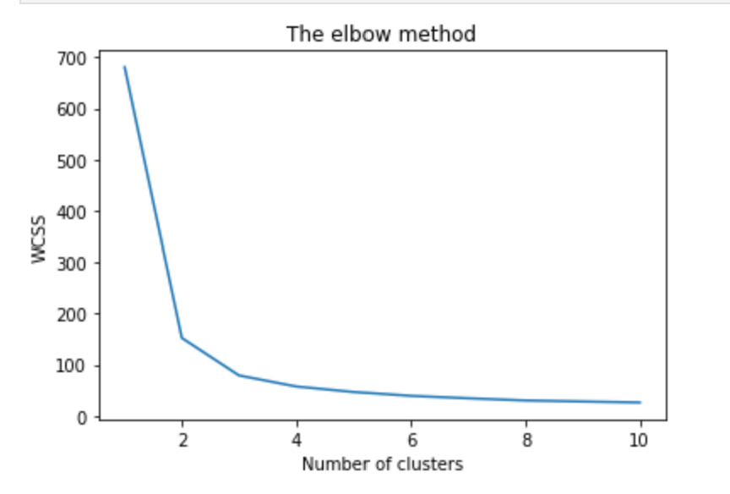

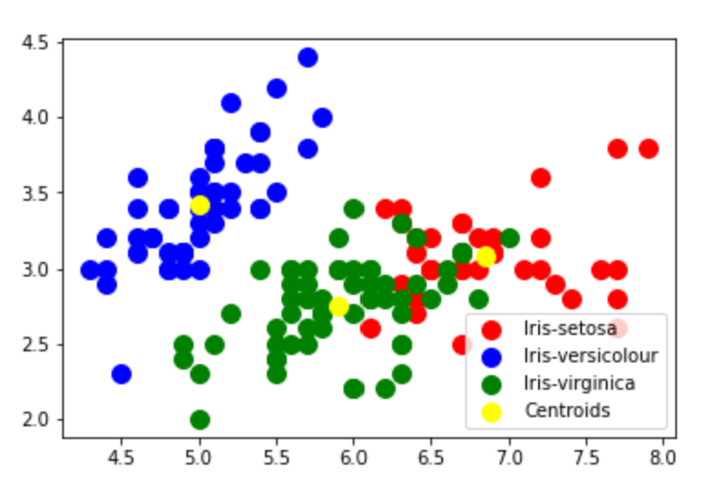

# Apply EM algorithm to cluster a set of data stored in a .CSV file.Compare the results of k-Means algorithm and EM algorithm

**import matplotlib.pyplot as plt**

**from sklearn import datasets**

**from sklearn.cluster import KMeans**

**import sklearn.metrics as sm**

**import pandas as pd**

**import numpy as np**

**iris = datasets.load_iris()**

**X = pd.DataFrame(iris.data)**

**X.columns = ['Sepal_Length','Sepal_Width','Petal_Length','Petal_Width']**

**y = pd.DataFrame(iris.target)**

**y.columns = ['Targets']**

**model = KMeans(n_clusters=3)**

**model.fit(X)**

**plt.figure(figsize=(14,7))**

**colormap = np.array(['red', 'lime', 'black'])**

***# Plot the Original Classifications***

**plt.subplot(1, 2, 1)**

**plt.scatter(X.Petal_Length, X.Petal_Width, c=colormap[y.Targets], s=40)**

**plt.title('Real Classification')**

**plt.xlabel('Petal Length')**

**plt.ylabel('Petal Width')**

***# Plot the Models Classifications***

**plt.subplot(1, 2, 2)**

**plt.scatter(X.Petal_Length, X.Petal_Width, c=colormap[model.labels_], s=40)**

**plt.title('K Mean Classification')**

**plt.xlabel('Petal Length')**

**plt.ylabel('Petal Width')**

**print('The accuracy score of K-Mean: ',sm.accuracy_score(y, model.labels_))**

**print('The Confusion matrixof K-Mean: ',sm.confusion_matrix(y, model.labels_))**

**from sklearn import preprocessing**

**scaler = preprocessing.StandardScaler()**

**scaler.fit(X)**

**xsa = scaler.transform(X)**

**xs = pd.DataFrame(xsa, columns = X.columns)**

***#xs.sample(5)***

**from sklearn.mixture import GaussianMixture**

**gmm = GaussianMixture(n_components=3)**

**gmm.fit(xs)**

**y_gmm = gmm.predict(xs)**

***#y_cluster_gmm***

**plt.subplot(2, 2, 3)**

**plt.scatter(X.Petal_Length, X.Petal_Width, c=colormap[y_gmm], s=40)**

**plt.title('GMM Classification')**

**plt.xlabel('Petal Length')**

**plt.ylabel('Petal Width')**

**print('The accuracy score of EM: ',sm.accuracy_score(y, y_gmm))**

**print('The Confusion matrix of EM: ',sm.confusion_matrix(y, y_gmm))**

**DATASET:**



**OUTPUT:**

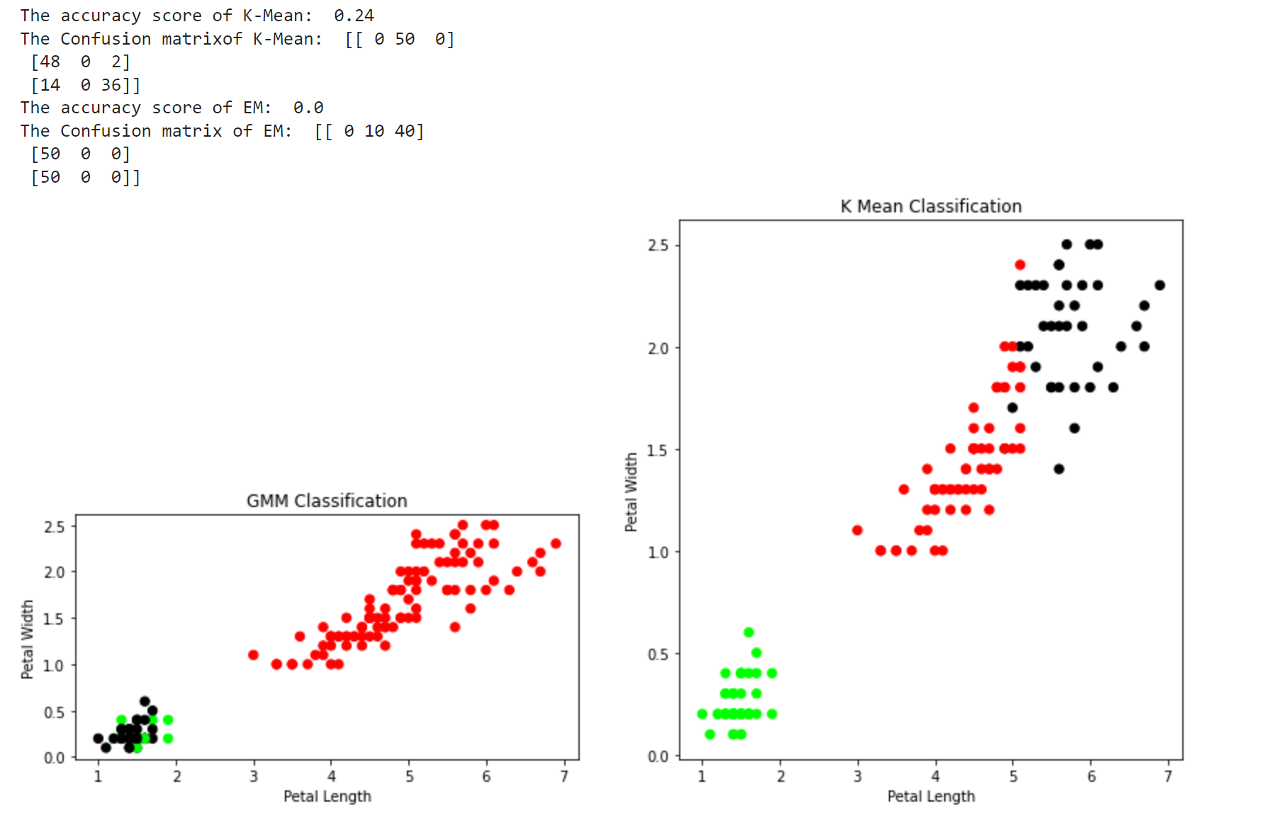

# Write a program to implement k-Nearest Neighbour algorithm to classify the iris data set.Print both correct and wrong predictions

**from sklearn.model_selection import train_test_split**

**from sklearn.neighbors import KNeighborsClassifier**

**from sklearn.metrics import classification_report, confusion_matrix**

**from sklearn import datasets**

**iris=datasets.load_iris()**

**x = iris.data**

**y = iris.target**

**print ('sepal-length', 'sepal-width', 'petal-length', 'petal-width')**

**print(x)**

**print('class: 0-Iris-Setosa, 1- Iris-Versicolour, 2- Iris-Virginica')**

**print(y)**

**x_train, x_test, y_train, y_test = train_test_split(x,y,test_size=0.3)**

***#To Training the model and Nearest nighbors K=5***

**classifier = KNeighborsClassifier(n_neighbors=5)**

**classifier.fit(x_train, y_train)**

***#To make predictions on our test data***

**y_pred=classifier.predict(x_test)**

**print('Confusion Matrix')**

**print(confusion_matrix(y_test,y_pred))**

**print('Accuracy Metrics')**

**print(classification_report(y_test,y_pred))**

**DATASET:**



**OUTPUT:**

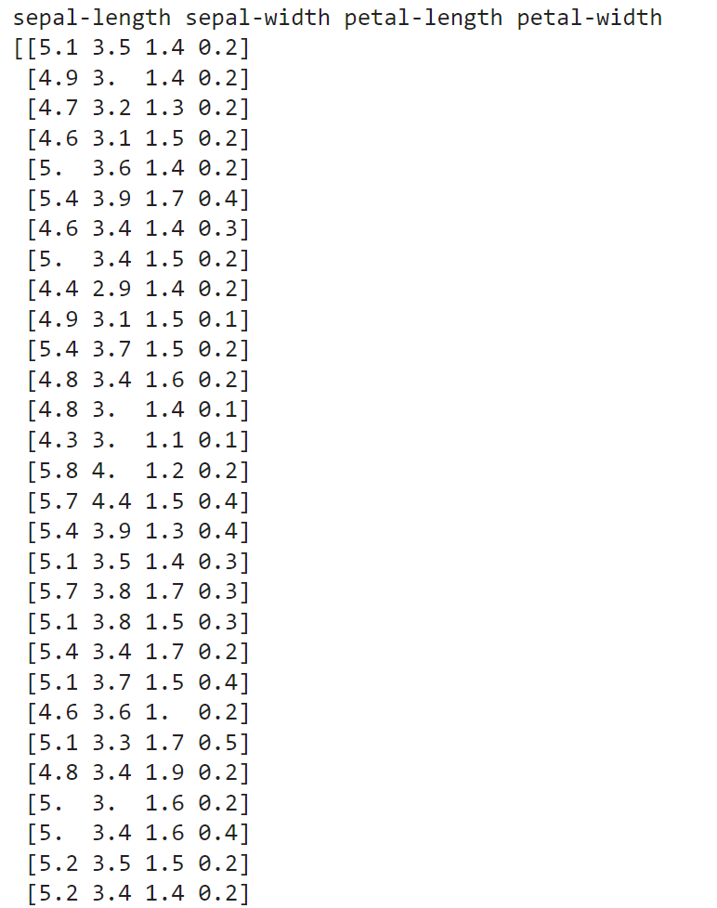

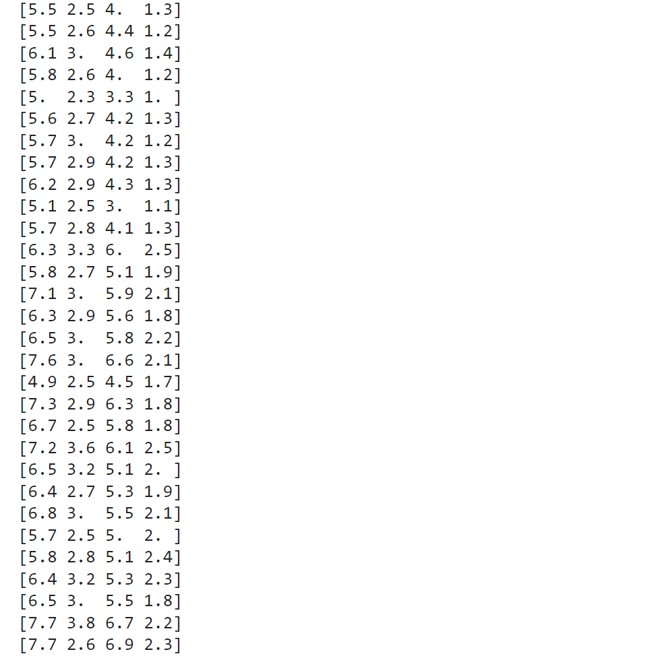

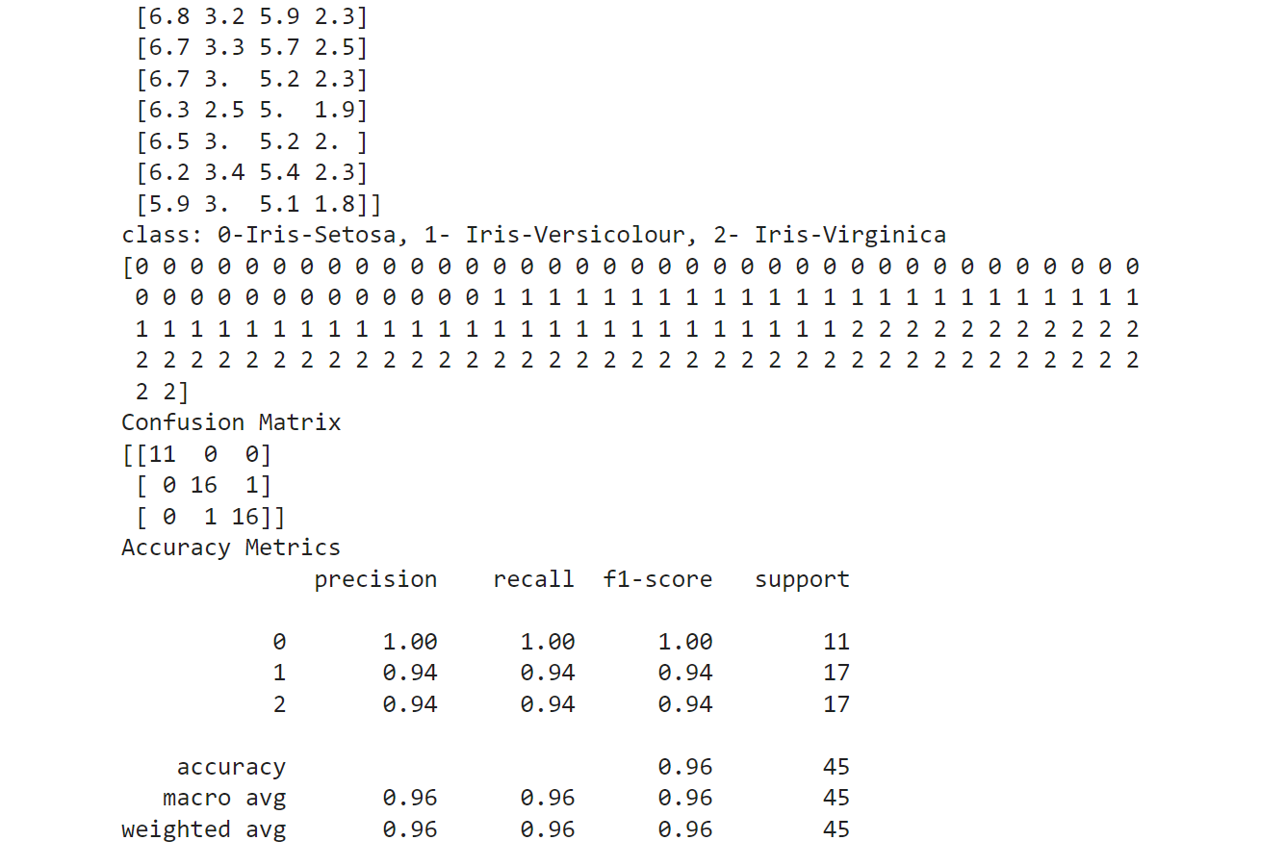

# Implement the non-parametric Locally Weighted Regression algorithm in order to fit data points. Select appropriate data set for your experiment and draw graphs.

**import** numpy **as** np

**from** bokeh.plotting **import** figure, show, output_notebook

**from** bokeh.layouts **import** gridplot

**from** bokeh.io **import** push_notebook

**from** matplotlib **import** pyplot **as** plt

**def** local_regression(x0, X, Y, tau):*# add bias term*

x0 **=** np**.**r_[1, x0] *# Add one to avoid the loss in information*

X **=** np**.**c_[np**.**ones(len(X)), X]

*# fit model: normal equations with kernel*

xw **=** X**.**T **\*** radial_kernel(x0, X, tau) *# XTranspose * W*

beta **=** np**.**linalg**.**pinv(xw **@** X) **@** xw **@** Y *#@ Matrix Multiplication or Dot Product*

*# predict value*

**return** x0 **@** beta *# @ Matrix Multiplication or Dot Product for prediction*

**def** radial_kernel(x0, X, tau):

**return** np**.**exp(np**.**sum((X **-** x0) **\*\*** 2, axis**=**1) **/** (**-**2 **\*** tau **\*** tau))

*# Weight or Radial Kernal Bias Function*

n **=** 1000

*# generate dataset*

X **=** np**.**linspace(**-**3, 3, num**=**n)

print("The Data Set ( 10 Samples) X :\n",X[1:10])

Y **=** np**.**log(np**.**abs(X **\*\*** 2 **-** 1) **+** .5)

print("The Fitting Curve Data Set (10 Samples) Y :\n",Y[1:10])

*# jitter X*

X **+=** np**.**random**.**normal(scale**=**.1, size**=**n)

print("Normalised (10 Samples) X :\n",X[1:10])

domain **=** np**.**linspace(**-**3, 3, num**=**300)

print(" Xo Domain Space(10 Samples) :\n",domain[1:10])

**def** plot_lwr(tau):

*# prediction through regression*

prediction **=** [local_regression(x0, X, Y, tau) **for** x0 **in** domain]

plot **=** figure(plot_width**=**400, plot_height**=**400)

plot**.**title**.**text**=**'tau=%g' **%** tau

plot**.**scatter(X, Y, alpha**=**.3)

plot**.**line(domain, prediction, line_width**=**2, color**=**'red')

**return** plot

show(gridplot([

[plot_lwr(10.), plot_lwr(1.)],

[plot_lwr(0.1), plot_lwr(0.01)]]))

plt**.**title('K Mean Classification')

plt**.**xlabel('Petal Length')

**DATASET:**

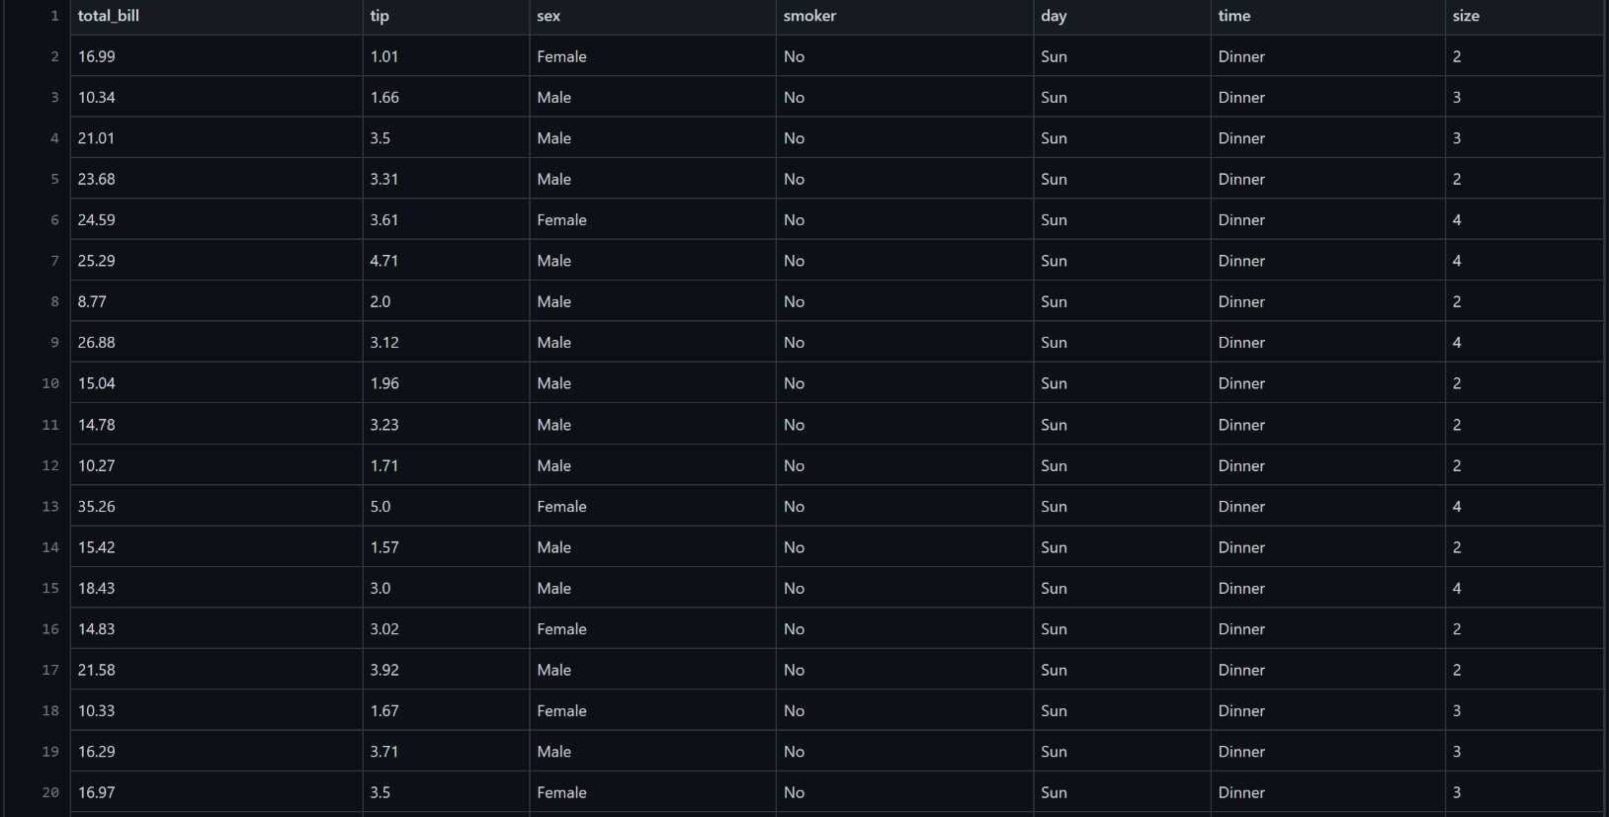

**OUTPUT:**

